Chiropractic registrant data: March 2015
Published May 2015

Introduction
The functions of the Chiropractic Board of Australia (the Board) include:
- registering the chiropractors and students
- developing standards, codes and guidelines for the chiropractic profession
- handling notifications, complaints, investigations and disciplinary hearings
- overseeing the assessment of overseas trained practitioners who wish to practise in Australia, and
approving accreditation standards and accredited courses of study.
The Board’s functions are supported by the Australian Health Practitioner Regulation Agency (AHPRA). For information about legislation governing our operations see AHPRA's Legislation & Publications at www.ahpra.gov.au/Publications
The Board has analysed its registration data and produced a number of statistical breakdowns about registrants to share with the profession and community. The Board shares these breakdowns regularly.
For more information on chiropractor registration, please see the Board’s website: http://www.chiropracticboard.gov.au/Registration.aspx

Contents
Chiropractic health practitioners – registration type and sub type by state or territory 3
Chiropractic health practitioners – percentage by principal place of practice 3
Chiropractic health practitioners – registration type and sub type by age group 4
Chiropractic health practitioners – by age group 5
Chiropractic health practitioners – registration type and sub type by gender 6
Chiropractic health practitioners – percentage by gender 6

Chiropractic health practitioners – registration type and sub type by state or territory
Chiropractic practitioners |  | Principal place of practice
Registration type | Registration subtype | ACT | NSW | NT | QLD | SA | TAS | VIC | WA | No PPP | Total
General |  | 62 | 1,620 | 24 | 750 | 346 | 49 | 1,214 | 580 | 43 | 4,688
Limited | Public interest |  |  |  |  |  |  |  |  | 1 | 1
 | Teaching or Research
Non-practising |  | 3 | 63 | 1 | 21 | 16 | 2 | 74 | 14 | 96 | 290
Total |  | 65 | 1,683 | 25 | 771 | 362 | 51 | 1,288 | 594 | 140 | 4,979

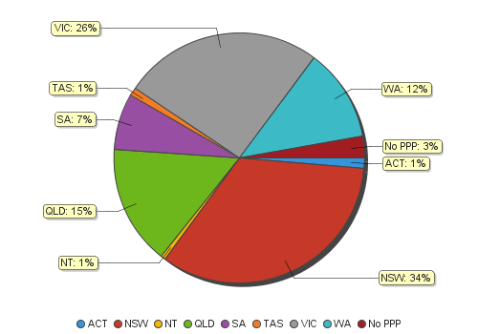
Chiropractic health practitioners – percentage by principal place of practice

Chiropractic health practitioners – registration type and sub type by age group
Chiropractic practitioners |  | Registration type and sub type
Age group |  | General | Limited |  | Non-practising | Total
 |  |  | Public interest | Teaching or research
U - 25 | 70 |  |  |  |  | 70
25 - 29 | 776 |  |  |  | 36 | 812
30 - 34 | 749 |  |  |  | 41 | 790
35 - 39 | 655 |  |  |  | 57 | 712
40 - 44 | 725 |  | 1 |  | 33 | 759
45 - 49 | 500 |  |  |  | 26 | 526
50 - 54 | 405 |  |  |  | 21 | 426
55 - 59 | 329 |  |  |  | 25 | 354
60 - 64 | 216 |  |  |  | 16 | 232
65 - 69 | 144 |  |  |  | 17 | 161
70 - 74 | 72 |  |  |  | 9 | 81
75 - 79 | 33 |  |  |  | 7 | 40
80+ | 14 |  |  |  | 2 | 16
Total | 4,688 |  | 1 |  | 290 | 4,979

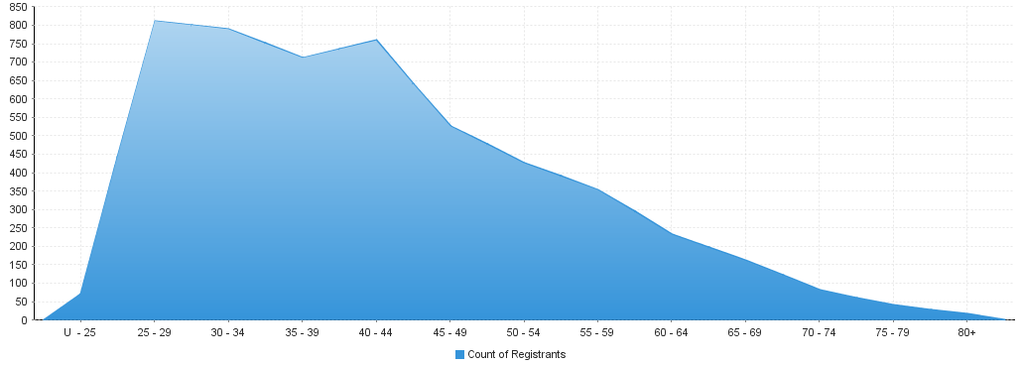
Chiropractic health practitioners – by age group
Age Group | U - 25 | 25 - 29 | 30 - 34 | 35 - 39 | 40 - 44 | 45 - 49 | 50 - 54 | 55 - 59 | 60 - 64 | 65 - 69 | 70 - 74 | 75 - 79 | 80+
Count of Registrants | 70 | 812 | 790 | 712 | 759 | 526 | 426 | 354 | 232 | 161 | 81 | 40 | 16

Chiropractic health practitioners – registration type and sub type by gender
Chiropractic health practitioners |  |  | Principal place of practice
Gender | Registration type | Registration sub type | ACT | NSW | NT | QLD | SA | TAS | VIC | WA | No PPP | Total
Female | General |  | 29 | 575 | 5 | 256 | 120 | 13 | 481 | 246 | 11 | 1,736
 | Limited | Public interest
 |  | Teaching or research
 | Non-practising |  | 2 | 33 | 1 | 7 | 7 | 1 | 40 | 4 | 34 | 129
Sub Total |  |  | 31 | 608 | 6 | 263 | 127 | 14 | 521 | 250 | 45 | 1,865
Male | General |  | 33 | 1,045 | 19 | 494 | 226 | 36 | 733 | 334 | 32 | 2,952
 | Limited | Public interest |  |  |  |  |  |  |  |  | 1 | 1
 |  | Teaching or research
 | Non-practising |  | 1 | 30 |  | 14 | 9 | 1 | 34 | 10 | 62 | 161
Sub Total |  |  | 34 | 1,075 | 19 | 508 | 235 | 37 | 767 | 344 | 95 | 3,114
Total |  |  | 65 | 1,683 | 25 | 771 | 362 | 51 | 1,288 | 594 | 140 | 4,979

Chiropractic health practitioners – percentage by gender
Chiropractic health practitioners | Principal place of practice
Gender | ACT | NSW | NT | QLD | SA | TAS | VIC | WA | No PPP | Total
Female | 47.69% | 36.13% | 24.00% | 34.11% | 35.08% | 27.45% | 40.45% | 42.09% | 32.14% | 37.46%
Male | 52.31% | 63.87% | 76.00% | 65.89% | 64.92% | 72.55% | 59.55% | 57.91% | 67.86% | 62.54%

