Market Research Report – FINAL
Online Survey of Registered Chiropractors

Research contact: Paul Di Marzio
Date submitted: 4 March, 2015


Table of Contents
Page
- Background, Objectives and Methodology 2
- Key Findings 4
- Conclusions and Recommendations 21
- Tabular Results 23

- Background, Objectives & Methodology

The Australian Health Practitioner Regulation Agency (AHPRA) is the body responsible for administering national registration for most of the allied health professions across Australia. AHPRA works in partnership with 14 health profession boards, including the Chiropractic Board of Australia (the Board), which was keen to engage key stakeholders (chiropractors) via an online survey to better understand their knowledge and perceptions about:
- Regulatory obligations under the National Law.
- Professional and ethical standards to adhere to.
- Operating in a practice, including regulatory and operational issues / challenges faced.
- The Board’s role and its performance.
- Communications received and whether there is scope for improvement.
- Continuing professional development (CPD) and education.
A benchmark survey was conducted for the Board in 2012 (by Di Marzio Research in conjunction with Market Access) where similar information objectives were addressed. Certain questions in the benchmark survey remained relevant allowing some comparison of results herein. The questionnaire administered for the 2014 survey is shown in Appendix 1.
The survey was sent to chiropractors via email on 1 December 2014 and closed on 19 December by which time we had achieved 868 responses. This was a good response rate, representing approximately 18% of the database.
It’s important to highlight that the survey invitations were sent by the Board with a survey link (hosted by us) embedded. This guaranteed the data collected would be confidential because practitioner details weren’t shared with a third party which also encouraged response.
The table overleaf compares the demographic profile of our survey sample (gender, age and work location) relative to the database of registered practising chiropractors.

Comparison of survey respondents against the registrant database – December 2014
Gender | Practising Chiropractors – December 2014
Gender | Registrant data  (4,684)  % | Survey sample  (864)  %
Male | 63 | 70
Female | 37 | 30

Age
Under 25 | 3 | 1
25-29 | 16 | 12
30-34 | 16 | 13
35-39 | 15 | 13
40-44 | 15 | 15
45-49 | 10 | 10
50-54 | 9 | 12
55-59 | 7 | 9
60+ | 10 | 15
Location
NSW | 34 | 31
Victoria | 26 | 26
Queensland | 16 | 16
South Australia | 7 | 9
Western Australia | 13 | 11
NT / ACT / Tasmania | 3 | 4
Note: The survey was open to non-practising members (4 responded) but the majority of questions were only relevant to practising chiropractors therefore we do not include non-practising member data in the table above.
Although there is some skew towards males and over 50s, the survey sample distribution matches the registrant distribution fairly closely on the above variables – most are males and aged 30-60 and the location spread is very much in line. Therefore, we can be confident the sample provides an accurate representation of practising chiropractors throughout Australia.
On the following pages we provide a detailed analysis of findings from this survey (with references to the Tabular Results) followed by conclusions and recommendations.

Key Findings
2.1: Demographic Profile and Work Situation
In comparison to 2012, we conducted more interviews overall (868 compared with 681) but our survey samples were fairly consistent in terms of demographic spread, work situation and location (as demonstrated in the figures and charts below). This indicates a good representation of registered chiropractors has been achieved.
Males still dominate the base although there are now slightly more female chiropractors. There has been little change in the age spread and the average age is 45 years.
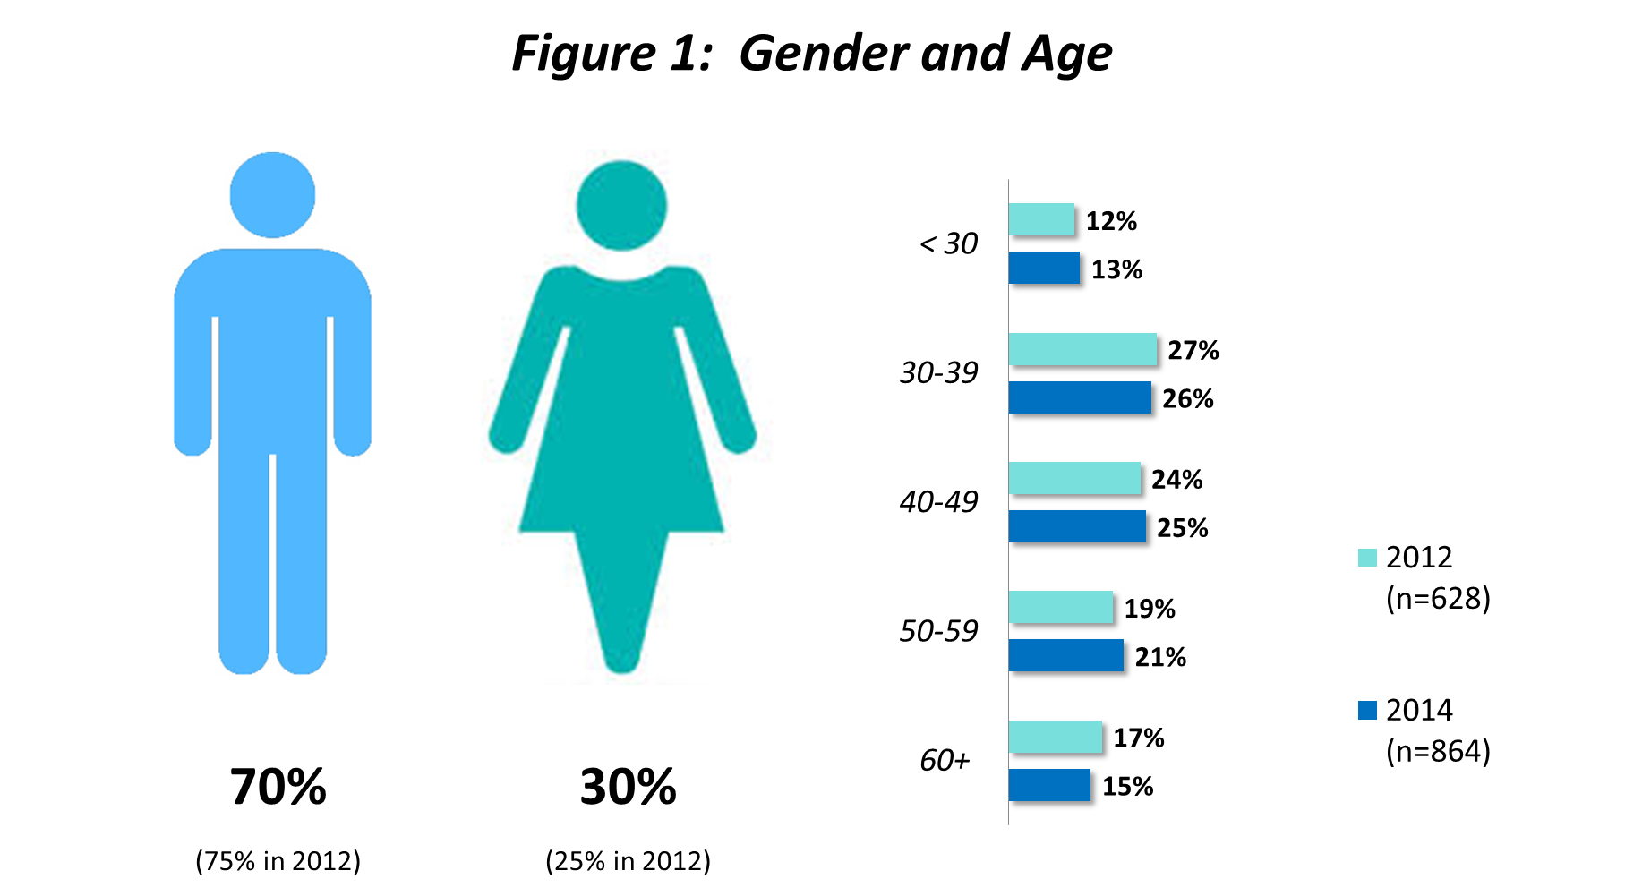

Chiropractors are still well spread across the country with a majority operating in metropolitan locations but quite a few are based in regional / rural areas. Some work across both (metropolitan and regional / rural locations) while a few are overseas based.

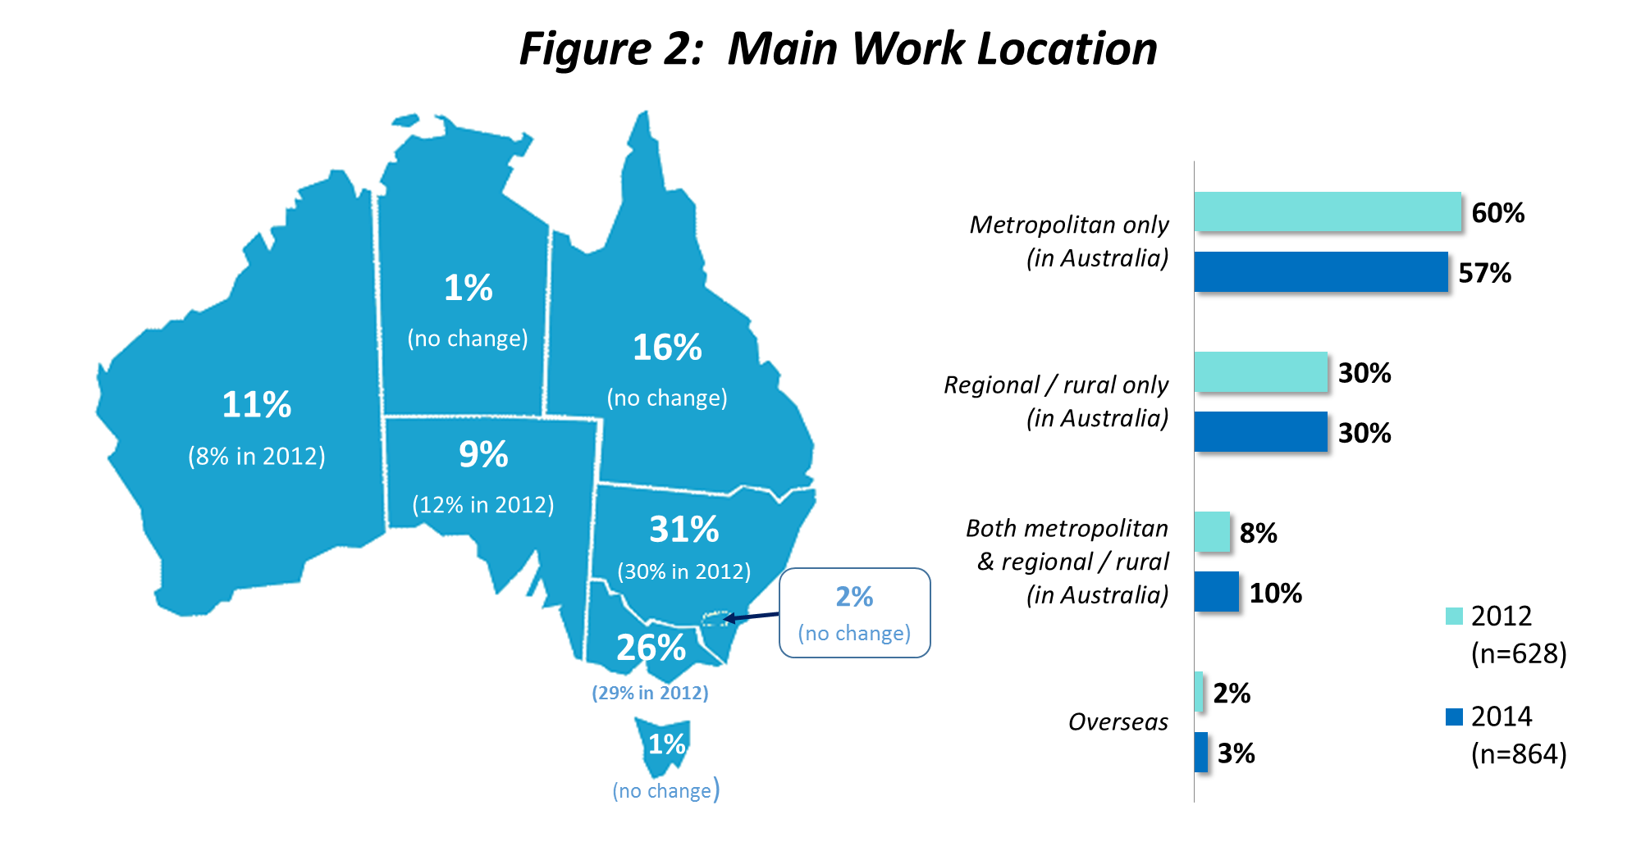
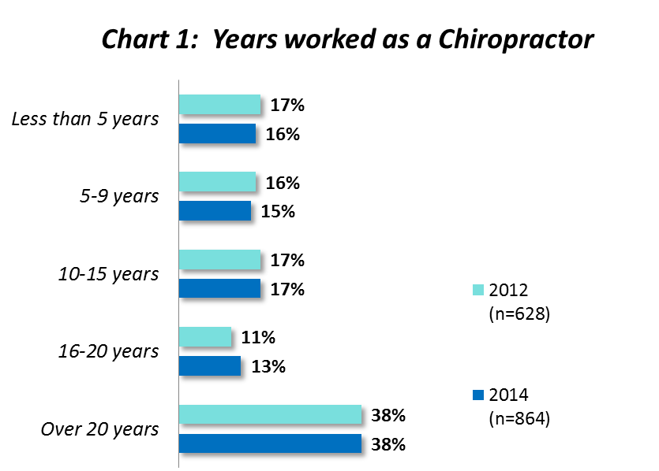
Chart 1 highlights that most chiropractors have at least 10 years experience (68%) and little has changed since 2012. The average length of time spent working as a chiropractor is 15 years.
Males tend to have worked in the profession for longer than females with 75% having worked for more than 10 years compared with 56% of females.
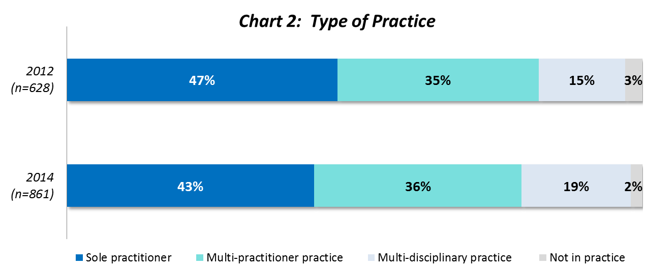
There are still quite a few sole practicioners working in the industry (albeit slightly fewer than in 2012). Chiropractiors working in multi-practitioner practices are still more common than those in a multi-disciplinary practice but they were not uncommon as can be seen in Chart 2.
Segments which stand out in each category, relatively speaking, are as follows:
Segment | Sole  Practitioners  (43%) | Multi-practitioner practice  (36%) | Multi-disciplinary practice  (19%)
Gender | Males:  45% c/w 36% of females | Females:  41% c/w 34% of males | No significant difference
Age | Older:  59% aged 50+ | Younger:  50% aged under 30 and 41% aged 30-39 | Younger:  27% aged under 40
Experience | More experienced:  57% 21+ years | Less experienced:  44% under 10 years | Less experienced:  27% under 10 years
Location | NSW / ACT based:  51% | QLD or SA based:  44% and 43% respectively | NT/TAS or WA based:  33% and 28% respectively

See also Tables 1-3 in the Tabular Results
2.2: Website Use and Opinions
Most have accessed the Board’s website (84%) but don’t use it very often (53% access it less than quarterly) as Chart 3 depicts.
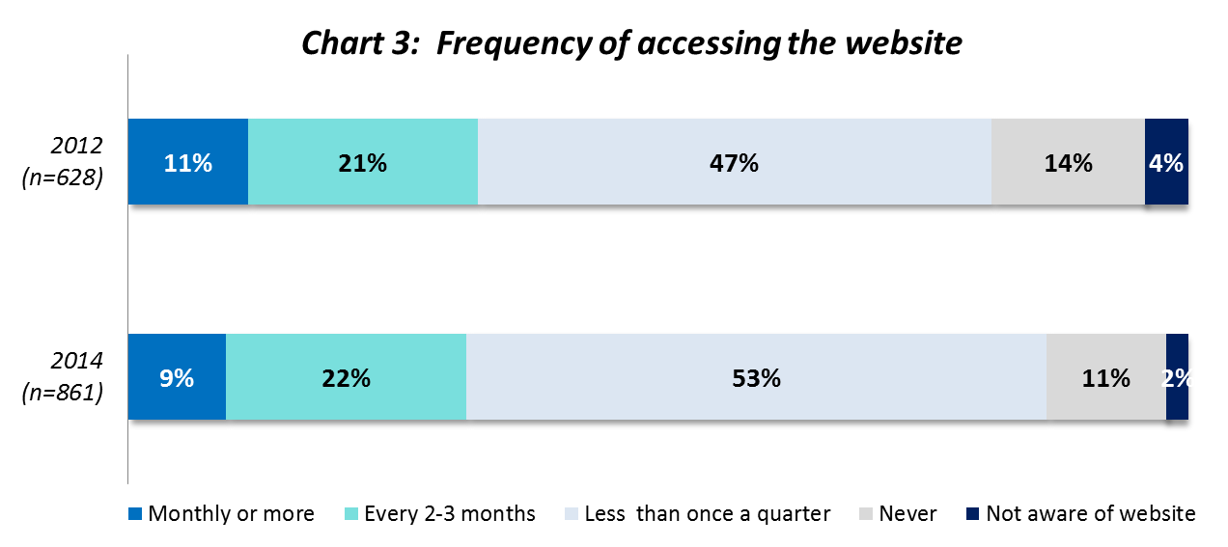
Note: Those saying don’t know not shown in Chart 3 above.

The results shown above are in line with 2012 but there has been a significant increase in the proportions who have now used each section of the site as highlighted in Chart 4.
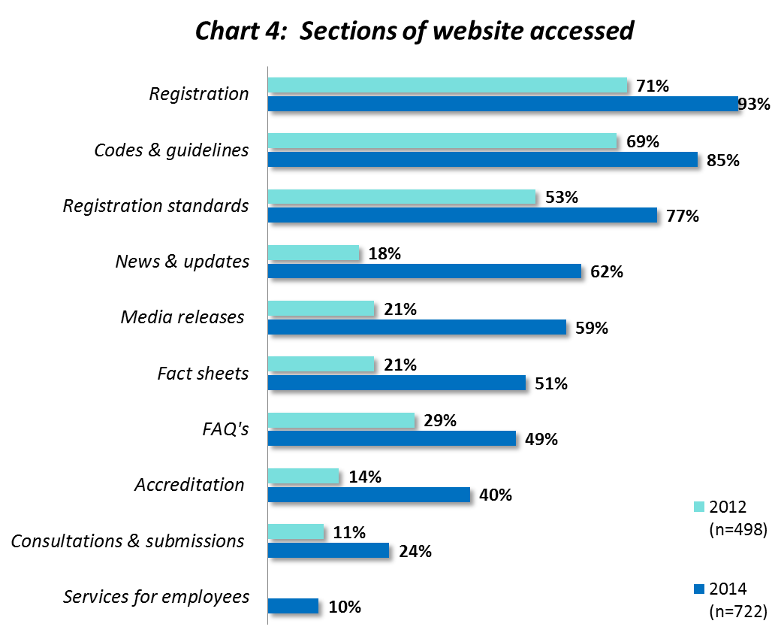
Notes:
- Results above based on those who have ever accessed the website.
- Services for employers not included in 2012 so no comparison available.

Quite a bit of time has elapsed since the previous survey so we suspect this explains why there’s been a shift but the growth observed here suggests website traffic has increased since then.
It appears that certain sections of the website have been accessed by some segments more than others. In most cases the older, more experienced practitioners stand out:
Section accessed | Segment/s standing out
Registration (93%) | - 5-9 years experience (97% c/w 91% with 10-20 years experience)
Codes and Guidelines (85%) | - Aged 50+ (90% c/w 80% aged under 30)  - 21+ years experience (90% c/w 78% under 5 years experience)
Registration Standards (77%) | - Aged 50+ (81% c/w 72% aged under 30)  - 21+ years experience (81% c/w 68% with 5-9 years experience)
News and Updates (62%) | - Aged 50+ (70% c/w 47% aged under 30)  - 21+ years experience (70% c/w 47% under 5 years experience)  - Sole practitioners (67% c/w 56% in multi-disciplinary practice)
Media Releases / Communiques (59%) | - Aged 50+ (63% c/w 52% aged under 30)  - Work in multi-disciplinary practice (63% c/w 53% in multi-practitioner practice)  - 21+ years experience (61% c/w 51% under 5 years experience)
Fact Sheets (51%) | - Work in multi-disciplinary practice (57% c/w 48% in multi-practitioner practice)  - 21+ years experience (55% c/w 45% with 10-20 years experience)
FAQ’s (49%) | - Work in metropolitan locations (52% c/w 45% working in regional / rural locations)
Accreditation (40%) | - Aged under 30 (46%) and 50+ (44% c/w 35% aged 30-49)  - Under 5 years experience (44%) or 21+ years experience (43% c/w 35% with 5-20 years experience)
Consultations and Submissions (24%) | - Aged 50+ (29% c/w 13% aged under 30)  - 21+ years experience (28% c/w 11% under 5 years experience)  - Males (28% c/w 14% females)
Services for Employers (10%) | - Work in multi-practitioner practice (13% c/w 8% of sole practitioners)
Note: c/w stands for compared with.
In an overall sense, those who have accessed the website remain far more positive than negative (in fact negative views are almost non-existent) but relative to 2012 neutral opinions have grown at the expense of those who were quite favourable as depicted in Chart 5 below. This suggests the website might not be quite as relevant to some chiropractors as it was two years ago.
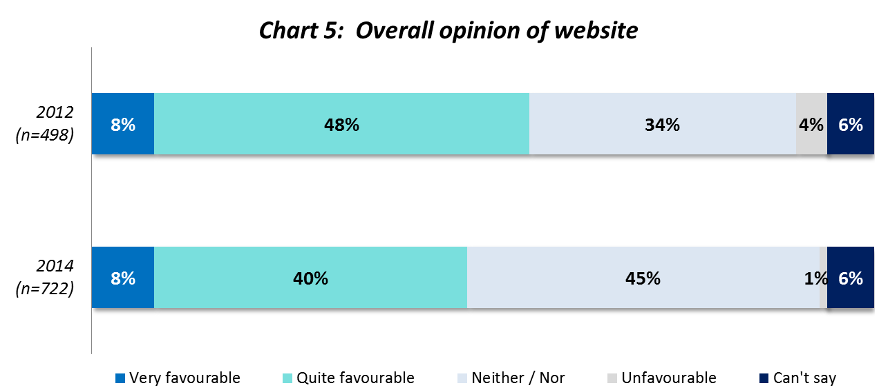

Note: Results above based on those who have ever accessed the website.
Furthermore, it seems the website appeals to slightly more practitioners in a multi-disciplinary practice – 54% are favourably disposed compared with 44% who work in a multi-practitioner practice.
See also Tables 4-6 in the Tabular Results
2.3: Information Needs and Communication Preferences
We again found high interest in all sources of information from the Board as Chart 6 displays. There was little change in results here and the information needs which remain most popular focus on regulatory, legislative or practical education and registration.
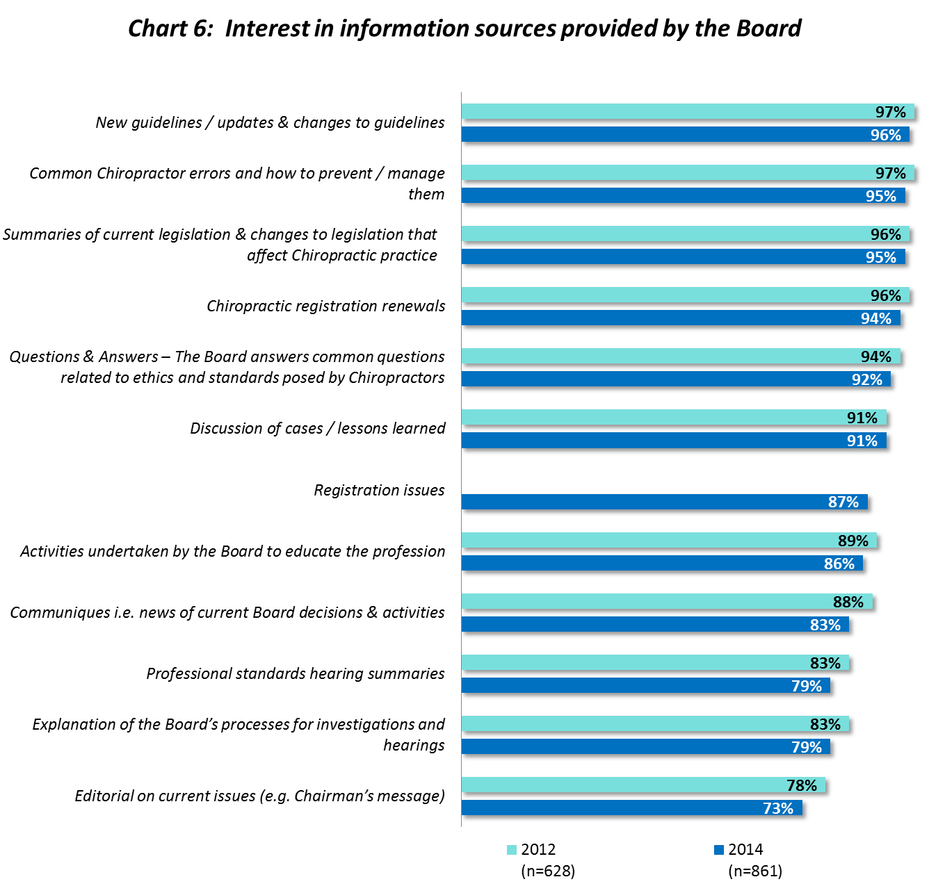
Note: Registration Issues not included in 2012 so no comparison available.
While most of this information is of interest to the vast majority, we note the following sources appeal to a greater proportion of older, more experienced chiropractors.
- Communiques i.e. news of current Board decisions & activities
  - 87% aged 50+ c/w 74% aged under 30
  - 88% with 21+ years experience c/w 77% under 5 years experience
- Editorial on current issues (e.g. Chairman’s message)
  - 80% aged 50+ c/w 66% aged under 30
  - 81% with 21+ years experience c/w 65% under 5 years experience
It’s pleasing to see in Chart 7 the increased proportions who feel ‘well informed’ by the Board about registration, CPD and professional requirements, obligations and responsibilities. This indicates improvement in communicating these important requirements.
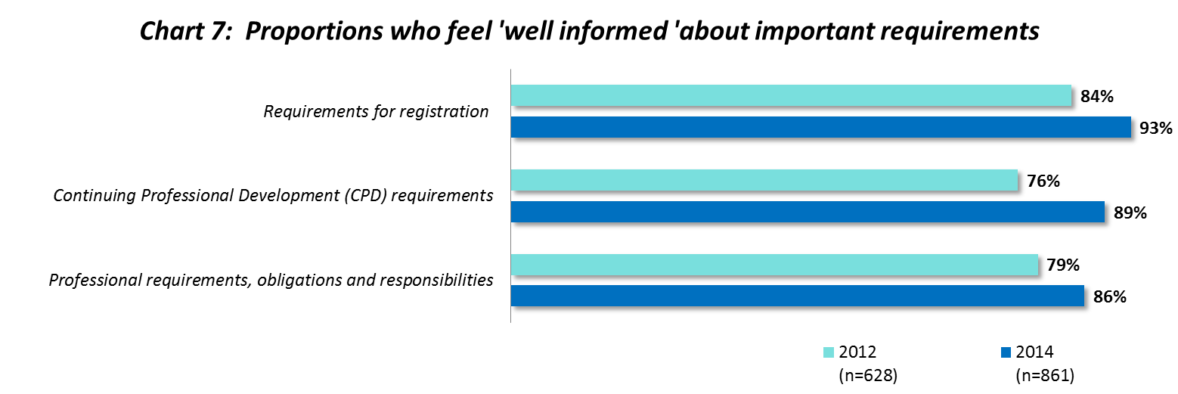

Some segments were more inclined to feel ‘neither well nor poorly informed’ or ‘poorly informed’ about their requirements which are identified below:
Requirements for registration  (7%) | CPD requirements  (11%) | Professional requirements, obligations & responsibilities  (14%)
Those working in QLD (11%) | Aged under 30 (16%)  Under 5 years experience (15%) | Aged under 30 (20%)

This provides guidance to assist with future communications targeting.
The most effective way to communicate with chiropractors is emailed newsletters and updates. Almost all (95%) selected this as their preferred communications method.
Other methods which appeal to solid minorities are shown in Chart 8 below.
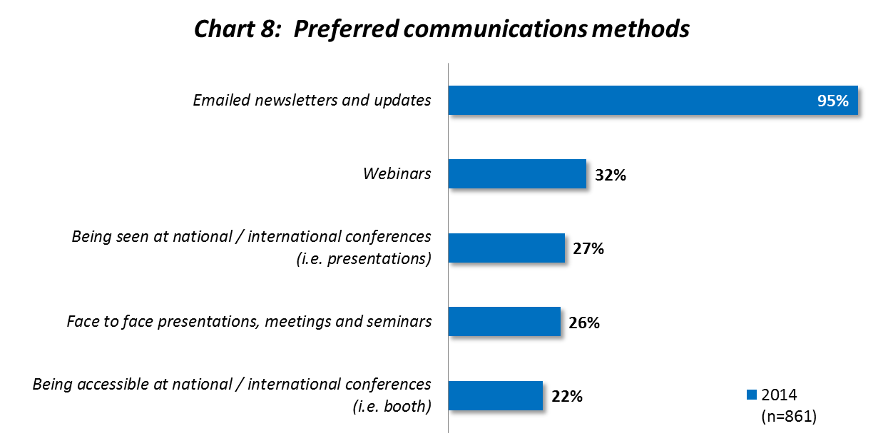
Note: A similar question was asked in 2012 but different response options were presented therefore comparisons are not shown.
Within segments of interest, communications preferences do not differ markedly from the total sample.
See also Tables 7-9 in the Tabular Results
2.4: Education and Professional Development
Conferences with assessed content and distance learning modules continue to be the most common formal learning activities pursued. The most popular informal learning activities are still self study options – reading journal articles and case study discussions as Chart 9 below reveals.
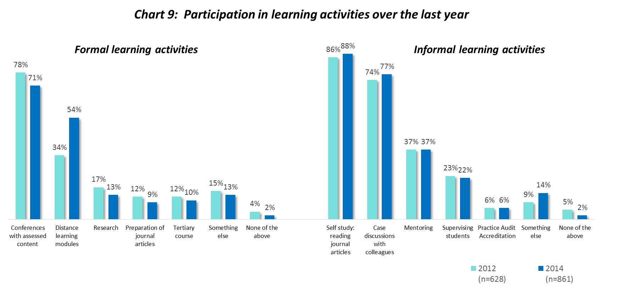
There have been some changes since 2012 in formal learning participation, most notably, an increase in distance learning modules completed (in the last year). This activity was popular, particularly in the following segments…
- Practitioners aged 40-49 (61%)
- Chiropractors based in Queensland (60%)
- Sole practitioners (58%)
We also found Conferences with assessed content were attended by above average proportions in:
- multi-practitioner practices (80% c/w 67% for both sole practitioners and those working in multi-disciplinary practices)
- both metropolitan and regional/rural locations (81% c/w 69% who work only in regional / rural locations and 71% who work only in metropolitan locations.
- SA and NSW (78% and 75% respectively c/w 60% of WA based chiropractors).
There was very little change in participation for all informal learning activities listed (c/w 2012). However, some significant differences between segments were apparent as per the table below:
Informal Learning Activity | Gender | Age | Experience | Practice Type | Location
Case study discussions with colleagues  (77%) | No difference | Younger:  86% aged < 30 | Less experienced:  83% < 10 years experience | Multiple employees:  83% Multi-practitioner  84% Multi-disciplinary | 91% working in metropolitan & regional / rural
Mentoring  (37%) | 41% males  27% females | Older:  41% aged 40-49 | More experienced:  41% with 5-9 years experience | Multiple employees:  43% Multi-practitioner  40% Multi-disciplinary | 40% working in metropolitan only
Supervision of students  (22%) | 25% males  15% females | No difference | No difference | 32% Multi-disciplinary | No difference
Note: No significant differences were found among segments for Self Study and Practice Audit / Accreditation.
Just over one in 10 chiropractors attended a forum (in a capital city) about advertising and the code of conduct last year as highlighted in Figure 3 below. Most (92%) found the information from this presentation useful and the 8% of chiropractors who didn’t provided reasons why (see Appendix 2). Quite a few chiropractors who didn’t attend claimed they were not aware of the sessions while distance and lack of time was a key deterrent for some.
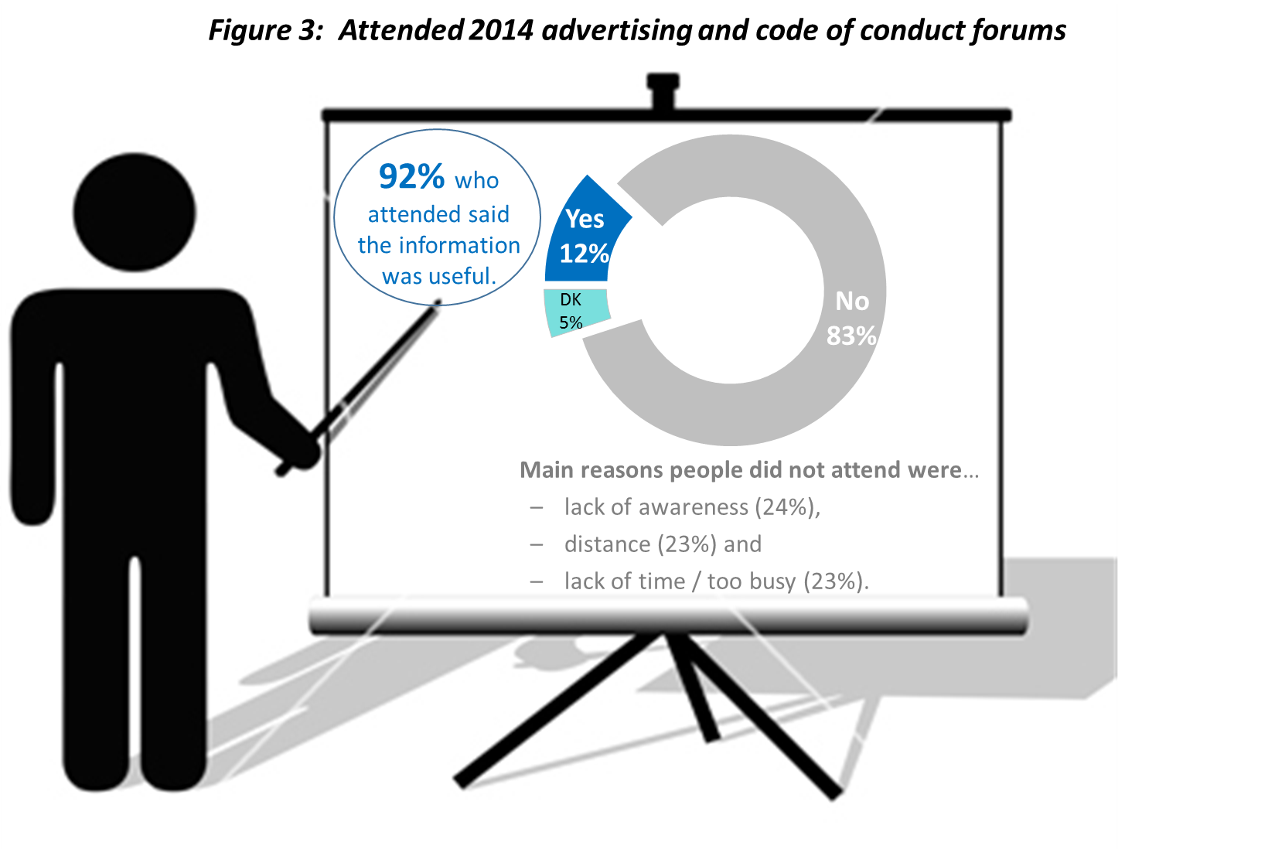There was a slightly higher incidence of delegates at these forums aged over 50 (14%) and fewer from the 30-39 age bracket (8%). As would be expected, metropolitan-based chiropractors were more prevelant (14%). However, there were some (8%) working in regional / rural locations who travelled to a capital city to attend.
Attendance by state resembled the total sample with the actual figures shown in the table below:
Attendance at advertising and code of conduct forum in 2014 by state
NSW / ACT | VIC | QLD | SA | WA
13% | 10% | 13% | 14% | 12%
Figure 4 illustrates that intentions to attend such forums in 2015 is solid as is the desire for such content to be made available via webinar and/or on a DVD.
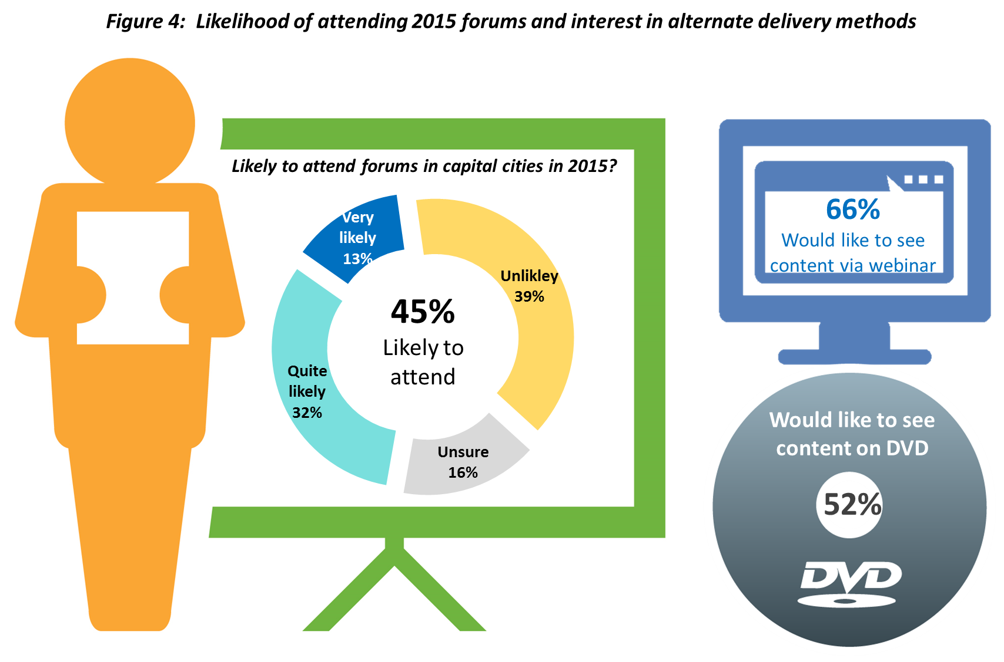

The table overleaf demonstrates that webinars appeal most to younger, less experienced chiropractors while the DVD is more popular for those who are older, more experienced and sole practitioners. Additionally, the webinar and DVD options are more popular for regional/rural based practitioners.

Segment | Likley to attend forums in 2015  (45%) | Like to see content via webinar  (66%) | Like to see content on DVD  (52%)
Age | Younger:  48% aged under 40  43% aged 40+ | Younger:  74% aged under 50  55% aged 50+ | Older:  54% aged 30+  39% aged under 30
Experience | Less experienced:  52% under 5 years  44% 5+ years | Less experienced:  76% under 10 years  58% 21+ years | More experienced:  55% 5+ years  40% under 5 years
State | 60% in WA  54% in SA | No significant difference | No significant difference
Location | 55% Metro based  29% Regional/rural based | 65% Metro based  68% Regional/rural based | 57% Regional/rural based  50% Metro based
Practice type | 50% working in Multi-practitioner practice | No significant difference | 56% Sole practitioners

Based on the relative popularity of webinar and DVD options, it may be worth producing this content via those media (instead of presenting face to face) as a more cost effective option to potentially attract a greater number of participants from across the country (and even overseas).
See also Tables 10-12 in the Tabular Results
2.5: Awareness of the Board’s Roles and Perceptions of it’s Performance
There is almost universal awareness of the Board’s roles (98% awareness) and the clear majority (around 70% or more) rates its performance in fulfilling these duties as good, very good or excellent as outlined in Figure 5 below.
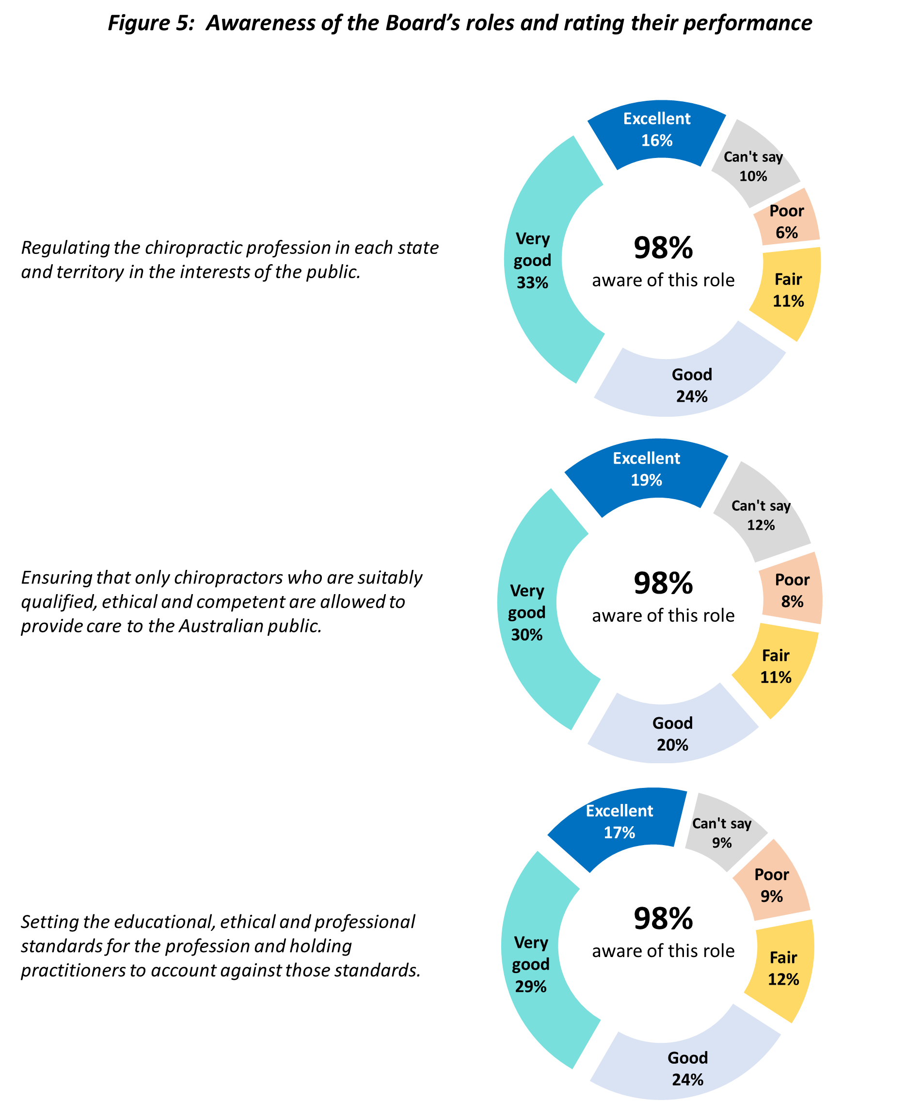
We also found females, those who are older, more experienced and Victorian-based chiropractors were more complimentary of the Board’s performance (i.e. gave an excellent or very good rating).

Segment | Rate the Board’s performance as excellent or very good for…
Segment | Regulating the chiropractic profession in each state and territory in the interests of the public  (49%) | Ensuring that only chiropractors who are suitably qualified, ethical and competent are allowed to provide care to the Australian public  (50%) | Setting the educational, ethical and professional standards for the profession and holding practitioners to account against those standards  (45%)
Gender | 55% females  46% males | 55% females  48% males | 51% females  43% males
Age | 53% aged 50+  46% aged under 50 | 55% aged 50+  46% aged under 40 | 53% aged 50+  41% aged under 50
Experience | 50% 5+ years  42% under 5 years | 53% 5+ years  38% under 5 years | 50% 21+ years  38% under 5 years
State | 52% in Victoria | 55% in Victoria | 48% in Victoria
Chiropractors who are male, younger, less experienced, working in NSW and in multi-disciplinary practices were more likely to be critical of the Board’s performance (with ratings of fair or poor).
Segment | Rate the Board’s performance as fair or poor for…
Segment | Regulating the chiropractic profession in each state and territory in the interests of the public  (17%) | Ensuring that only chiropractors who are suitably qualified, ethical and competent are allowed to provide care to the Australian public  (19%) | Setting the educational, ethical and professional standards for the profession and holding practitioners to account against those standards  (21%)
Gender | 19% males  13% females | 21% males  14% females | 25% males  14% females
Age | 23% aged under 30  15% aged 40+ | 28% aged under 30  15% aged 40+ | 32% aged under 30  16% aged 50+
Experience | 22% under 5 years  15% 10+ years | 29% under 5 years  16% 10+ years | 28% under 5 years  19% 10+ years
State | 20% in NSW  14% in Victoria | 22% in NSW  15% in Victoria | 26% in NSW  19% in Victoria
Practice Type | 21% in multi- disciplinary practices  16% other practice types | 22% in multi- disciplinary practices  17% other practice types | 28% in multi- disciplinary practices  19% other practice types
- Conclusions and recommendations
The Chiropractic Board of Australia has been quite effective from a communications standpoint, especially in keeping chiropractors well informed about the important issues of registration, CPD and professional requirements. News, changes or updates about these topics appear to be what chiropractors are most interested in hearing from the Board. Clearly the current strategy has been working well so we suggest continuing with this approach, keeping in mind that nearly all chiropractors’ communications preference is emailed newsletters and updates.
Webinars seem to be popular and potentially more effective for delivering content than face-to-face presentations. We recommend this as an alternative option for future forums as they are easily accessible (particularly for regional / rural practitioners) and generally more cost effective. However, if face-to-face presentations are necessary, also offering it as a webinar and/or producing a DVD of the content is a good idea for those who cannot attend.
Although the website is not frequently accessed by most chiropractors, it seems the traffic has increased (relative to 2012). We suspect most chiropractors tend to access this resource only when the need arises but the information which is available seems to satisfy their needs. Nevertheless, increased neutral opinions towards the site suggests it could be less relevant to some chiropractors now (relative to 2012).
Practitioners’ CPD activity is pretty consistent with 2012 although more have completed distance learning modules in the last 12 months. They tend to complete a variety of formal and informal learning activities. The results of this survey suggest most practitioners are accepting of the CPD program although some have an issue with how it is regulated and assessed. We heard calls for a review to ensure any practical content being presented is evidence-based and for the Board to be the only evaluator of CPD points (not other agencies).
Chiropractors know and understand the Board’s role and responsibilities with most strongly endorsing them for how they have performed here. Although the survey results have generally been complimentary of their overall performance, there were some criticisms heard, particularly about the following issues which may require some attention:
- Registration fees
- CPD regulation
- Lobbying on behalf of the profession
- Reviews / reporting of complaints or unethical practice
- Poor training at university level
Finally, we would encourage the Board to consider sharing the results of this survey.

Table 1: Type of Respondent, Gender & Age
Q1: Firstly, which of these descriptions applies to you? (Single response)
A: Are you…? (Single response)
B: Are you aged…? (Single response)
Type of respondent | Total Sample
Type of respondent | 2012  (628)  % | 2014  (868)  %
I am or was a practising chiropractor | NA | 100
I am or was a health care professional working in another field | NA | 0
Neither of the above apply to me | NA | 0

Gender
Male | 75 | 70
Female | 25 | 30

Age
Under 25 | 3 | 1
25-29 | 9 | 12
30-34 | 15 | 13
35-39 | 12 | 13
40-44 | 14 | 15
45-49 | 10 | 10
50-54 | 11 | 12
55-59 | 8 | 9
60+ | 17 | 15
Mean Age | 44 | 45

Source: Detailed Tabular Results – Tables 1-2 & 95-98
Notes:
- Q1 not asked in 2012 therefore no comparison available.
- 0 = Less than 1%

Table 2: Years Worked and Work Situation
Q2: How long have you worked, or did you work, as a chiropractor? (Single response)
Q3: Do you currently work, or did you work …? (Single response)
Years worked as a chiropractor | Total Sample |  | 2014 Results by segment
Years worked as a chiropractor | 2012  (628)  % | 2014  (864)  % | Gender |  | Age
Years worked as a chiropractor | 2012  (628)  % | 2014  (864)  % | Male  (608)  % | Female  (256)  % | <30  (111)  % | 30-39  (223)  % | 40-49  (215)  % | 50+  (311)  %
Less than 2 years | 10 | 5 | 4 | 9 | 29 | 4 | 1 | 1
2-4 years | 7 | 11 | 10 | 15 | 50 | 15 | 3 | 0
5-9 years | 16 | 15 | 12 | 20 | 20 | 38 | 7 | 1
10-15 years | 17 | 17 | 16 | 18 | - | 39 | 22 | 3
16-20 years | 11 | 13 | 13 | 15 | - | 4 | 38 | 8
21-30 years | 19 | 19 | 21 | 16 | - | - | 28 | 34
More than 30 years | 19 | 19 | 24 | 7 | - | - | 1 | 51
Mean years working | 17 | 15 | 16 | 12 | 3 | 9 | 16 | 22

Work Situation
As a sole practitioner | 47 | 43 | 45 | 36 | 21 | 30 | 44 | 59
In a multi-practitioner practice | 35 | 36 | 34 | 41 | 50 | 41 | 36 | 28
In a multi-disciplinary practice | 15 | 19 | 19 | 20 | 25 | 28 | 18 | 11
Not in a practice | 3 | 2 | 2 | 3 | 5 | 1 | 1 | 2

Source: Detailed Tabular Results – Tables 3-6
Notes:
- Blue and red figures indicate differences against the total sample and between age segments that are respectively higher and lower to a statistically significant degree at the 95% confidence level.
- 0 = Less than 1%.
- Note: Questions asked only of practising chiropractors (found in Q1)
Table 3: Main Work Location
Q4: And is, or was, your place of work in…? (If more than one applies, please select the place where you conduct the majority of your work)
Q5: And do you, or did you, work in…? (If more than one applies, please select the place where you conduct the majority of your work)
State | Total Sample |  | 2014 Results by segment
State | 2012  (628)  % | 2014  (864)  % | Gender |  | Age
State | 2012  (628)  % | 2014  (864)  % | Male  (608)  % | Female  (256)  % | <30  (111)  % | 30-39  (223)  % | 40-49  (215)  % | 50+  (311)  %
NSW | 30 | 31 | 32 | 29 | 32 | 33 | 29 | 31
Victoria | 29 | 26 | 26 | 26 | 23 | 24 | 27 | 28
Queensland | 16 | 16 | 16 | 17 | 16 | 15 | 18 | 16
South Australia | 12 | 9 | 9 | 9 | 5 | 9 | 8 | 10
Western Australia | 8 | 11 | 11 | 11 | 16 | 13 | 11 | 8
NT / ACT / Tasmania | 2 | 4 | 5 | 5 | 8 | 2 | 2 | 4
Overseas | 1 | 3 | 2 | 3 | 1 | 3 | 4 | 2

Location
Metropolitan areas only (in Australia) | 60 | 57 | 57 | 57 | 57 | 63 | 63 | 49
Regional / rural areas only (in Australia) | 30 | 30 | 31 | 29 | 28 | 25 | 25 | 38
Both metropolitan and regional / rural areas (in Australia) | 8 | 10 | 10 | 11 | 14 | 9 | 8 | 10
Overseas | 2 | 3 | 3 | 3 | 1 | 4 | 4 | 3

Source: Detailed Tabular Results – Tables 7-10
Notes:
- Blue and red figures indicate differences against the total sample and between age segments that are respectively higher and lower to a statistically significant degree at the 95% confidence level.
- 0 = Less than 1%.
- Note: Questions asked only of practising chiropractors (found in Q1)
Table 4: Frequency of Accessing the Chiropractic Board of Australia Website
Q6: On average, how often, if at all, do you access the Chiropractic Board of Australia website: www.chiropracticboard.gov.au? Is it…?
Frequency of accessing website | Total Sample |  | 2014 Results by segment
Frequency of accessing website | 2012  (628)  % | 2014  (864)  % | Gender |  | Age
Frequency of accessing website | 2012  (628)  % | 2014  (864)  % | Male  (608)  % | Female  (256)  % | <30  (111)  % | 30-39  (223)  % | 40-49  (215)  % | 50+  (311)  %
Once a week or more often | 1 | 0 | 0 | 0 | - | - | 0 | 1
Once every 2-3 weeks | 3 | 2 | 2 | 3 | 7 | 2 | 1 | 2
Monthly | 7 | 7 | 7 | 6 | 10 | 4 | 8 | 6
Every 2-3 months | 21 | 22 | 21 | 22 | 15 | 17 | 25 | 25
Less often than once a quarter | 47 | 53 | 52 | 55 | 46 | 57 | 51 | 53
Total monthly or more | 11 | 9 | 10 | 9 | 17 | 6 | 9 | 9
Total less than monthly | 68 | 74 | 73 | 77 | 61 | 74 | 75 | 78
Never | 14 | 11 | 12 | 10 | 15 | 14 | 11 | 9
Did not know that this website existed before now | 4 | 2 | 2 | 2 | 4 | 2 | 3 | 1
Don’t know / Can’t say | 3 | 3 | 3 | 2 | 3 | 4 | 2 | 4

Source: Detailed Tabular Results – Tables 11-12
Notes:
- Blue and red figures indicate differences against the total sample and between age segments that are respectively higher and lower to a statistically significant degree at the 95% confidence level.
- Total monthly or more = Once a week or more often + Once very 2-3 weeks + Monthly
- Total less than monthly = Every 2-3 months + Less often than once a quarter
- 0 = Less than 1%.
- Rounding occurs
- Note: Questions asked only of practising chiropractors (found in Q1)
Table 5: Website Sections Used
(Among those who have accessed the website)
Q7: And which of these sections of the website have you ever used?
Sections Used | Accessed Website |  | 2014 Results by segment
Sections Used | 2012  (498)  % | 2014  (722)  % | Gender |  | Age
Sections Used | 2012  (498)  % | 2014  (722)  % | Male  (502)  % | Female  (220)  % | <30  (87)  % | 30-39  (179)  % | 40-49  (182)  % | 50+  (270)  %
Registration | 71 | 93 | 92 | 95 | 93 | 93 | 93 | 93
Codes and Guidelines | 69 | 85 | 85 | 85 | 80 | 82 | 85 | 90
Registration Standards | 53 | 77 | 77 | 77 | 72 | 74 | 76 | 81
News and Updates | 18 | 62 | 63 | 60 | 47 | 59 | 60 | 70
Media Releases / Communiques | 21 | 59 | 59 | 57 | 52 | 60 | 54 | 63
Fact Sheets | 21 | 51 | 49 | 53 | 52 | 47 | 47 | 55
FAQ’s (Frequently Asked Questions) | 29 | 49 | 48 | 51 | 44 | 50 | 51 | 48
Accreditation | 14 | 40 | 41 | 36 | 46 | 34 | 36 | 44
Consultations and Submissions | 11 | 24 | 28 | 14 | 13 | 23 | 24 | 29
Services for Employers | NA | 10 | 10 | 10 | 11 | 8 | 9 | 12

Source: Detailed Tabular Results – Tables 13-32
Notes:
- Q7 only asked of those who have ever accessed the website in Q6.
- Blue and red figures indicate differences against the total sample and between age segments that are respectively higher and lower to a statistically significant degree at the 95% confidence level.
- Note: Questions asked only of practising chiropractors (found in Q1)

Table 6: Overall Opinion of the Website
(Among those who have accessed it)
Q8: And is your overall opinion of the website…?
Overall opinion | Accessed Website |  | 2014 Results by segment
Overall opinion | 2012  (498)  % | 2014  (722)  % | Gender |  | Age
Overall opinion | 2012  (498)  % | 2014  (722)  % | Male  (502)  % | Female  (220)  % | <30  (87)  % | 30-39  (179)  % | 40-49  (182)  % | 50+  (270)  %
Very favourable | 8 | 8 | 7 | 10 | 6 | 7 | 7 | 11
Quite favbourable | 48 | 40 | 42 | 36 | 43 | 40 | 39 | 40
Neither favourable nor unfavourable | 34 | 45 | 45 | 45 | 44 | 45 | 47 | 43
Unfavourable | 4 | 1 | 1 | 1 | 1 | 3 | - | 1
Can’t say | 6 | 6 | 5 | 7 | 7 | 5 | 7 | 5
Total Favourable | 56 | 48 | 49 | 47 | 48 | 46 | 46 | 51

Source: Detailed Tabular Results – Tables 33-34
Notes:
- Q8 only asked of those who have ever accessed the website in Q6.
- Total Favourable = Very + Quite favourable
- Blue and red figures indicate differences against the total sample and between age segments that are respectively higher and lower to a statistically significant degree at the 95% confidence level.
- Note: Questions asked only of practising chiropractors (found in Q1)

Table 7: Level of Interest in Different Information Sources Provided by the Board
Q9: Please indicate whether you would have ‘a lot of interest’, ‘some’, ‘little or no interest’ in the following information being provided to you by the Chiropractic Board? (Rotate order)
Information source | Total Sample (2014) |  |  |  | Total Interested
Information source | A lot of interest  % | Some interest  % | Little or no interest  % | Can’t say  % | 2014  (864)  % | 2012  (628)  %
New guidelines / updates & changes to guidelines | 65 | 31 | 3 | 1 | 96 | 97
Common chiropractor errors and how to prevent / manage them | 65 | 30 | 5 | 1 | 95 | 97
Summaries of current legislation & changes to legislation that affect chiropractic practice | 61 | 34 | 5 | 0 | 95 | 96
Chiropractic registration renewals | 67 | 26 | 6 | 1 | 94 | 96
Questions & Answers – The board answers common questions related to ethics and standards posed by chiropractors | 47 | 45 | 8 | 1 | 92 | 94
Discussion of cases / lessons learned | 51 | 40 | 8 | 1 | 91 | 91
Registration issues | 40 | 48 | 11 | 1 | 87 | NA
Activities undertaken by the Board to educate the profession | 35 | 52 | 12 | 1 | 86 | 89
Communiques i.e. news of current Board decisions & activities | 30 | 53 | 16 | 2 | 83 | 88
Professional standards hearing summaries | 32 | 47 | 19 | 2 | 79 | 83
Explanation of the Board’s processes for investigations and hearings | 31 | 48 | 19 | 2 | 79 | 83
Editorial on current issues (e.g. Chairman’s message) | 22 | 51 | 25 | 2 | 73 | 78

Source: Detailed Tabular Results – Tables 35-58
Notes:
- Total sample results for 2014 shown only. Space preclude showing results by segment.
- Total Interested = A lot of interest + some interest
- Rounding occurs
- NA – Not asked in 2012
- Note: Questions asked only of practising chiropractors (found in Q1)
Table 8: Preferred Communications Methods
Q10: Which of the following communication methods, if any, would you like to see the Chiropractic Board use to communicate with you? (MULTIPLES ALLOWED)
Communications Methods | Total Sample  (864)  % | Results by segment
Communications Methods | Total Sample  (864)  % | Gender |  | Age
Communications Methods | Total Sample  (864)  % | Male  (608)  % | Female  (256)  % | <30  (111)  % | 30-39  (223)  % | 40-49  (215)  % | 50+  (311)  %
Emailed newsletters and updates | 95 | 95 | 94 | 92 | 96 | 95 | 95
Webinars | 32 | 30 | 36 | 31 | 33 | 37 | 28
Being seen at national / international conferences (i.e. presentations) | 27 | 27 | 27 | 29 | 27 | 24 | 29
Face to face presentations, meetings and seminars | 26 | 26 | 26 | 23 | 23 | 27 | 28
Being accessible at national / international conferences (i.e. booth) | 22 | 22 | 23 | 18 | 22 | 24 | 22
Other | 3 | 3 | 1 | 3 | 2 | 2 | 4
Don’t know | 2 | 1 | 3 | 2 | 2 | 2 | -

Source: Detailed Tabular Results – Tables 59-60
Notes:
- Response options changed in 2014 so direct comparisons unavailable.
- Blue and red figures indicate differences against the total sample and between age segments that are respectively higher and lower to a statistically significant degree at the 95% confidence level.
- Note: Questions asked only of practising chiropractors (found in Q1)

Table 9: Perceptions on Being Informed About Important Requirements
Q11: How well informed or otherwise do you feel about the following requirements: Do you feel very well informed, quite well informed, neither well informed nor poorly informed, or poorly informed?
Requirements | Total Sample (2014) |  |  |  |  | Total  Well Informed
Requirements | Very well informed  % | Quite well informed  % | Neither / nor  % | Poorly informed  % | Don’t know  % | 2014  (864)  % | 2012  (628)  %
Requirements for registration | 49 | 44 | 5 | 2 | 0 | 93 | 84
Continuing Professional Development (CPD) requirements | 48 | 41 | 8 | 3 | 0 | 89 | 76
Professional requirements, obligations and responsibilities | 31 | 55 | 10 | 3 | 0 | 86 | 79

Source: Detailed Tabular Results – Tables 61-66
Notes:
- Total sample results for 2014 shown only. Space preclude showing results by segment.
- Total well Informed = Very well informed + Quite well informed
- Note: Questions asked only of practising chiropractors (found in Q1)
- Rounding occurs
- 0 = Less than 1%

Table 10: Participation in Learning Activities
Q12: In which of the following, formal learning activities, have you engaged in the last 12 months? Please select all that apply (MULTIPLES ALLOWED)
Q13: In which of the following, informal learning activities, have you engaged in the last 12 months? Please select all that apply (MULTIPLES ALLOWED)
Formal learning activities | Total Sample |  | 2014 Results by segment
Formal learning activities | 2012  (628)  % | 2014  (864)  % | Gender |  | Age
Formal learning activities | 2012  (628)  % | 2014  (864)  % | Male  (608)  % | Female  (256)  % | <30  (111)  % | 30-39  (223)  % | 40-49  (215)  % | 50+  (311)  %
Conferences with assessed content | 78 | 71 | 70 | 71 | 69 | 70 | 73 | 70
Distance learning modules | 34 | 54 | 56 | 51 | 52 | 50 | 61 | 54
Research | 17 | 13 | 14 | 9 | 19 | 9 | 9 | 15
Tertiary course | 12 | 10 | 11 | 9 | 15 | 9 | 7 | 10
Preparation of journal articles | 12 | 9 | 10 | 7 | 12 | 5 | 8 | 11
None of the above | 4 | 2 | 2 | 1 | 2 | 1 | 1 | 2
Something else | 15 | 13 | 14 | 11 | 5 | 12 | 11 | 18

Informal learning activities
Self study – reading journal articles | 86 | 88 | 88 | 89 | 93 | 87 | 87 | 88
Case discussions with colleagues | 74 | 77 | 76 | 80 | 86 | 81 | 82 | 69
Mentoring | 37 | 37 | 41 | 27 | 32 | 38 | 41 | 36
Supervision of students | 23 | 22 | 25 | 15 | 20 | 25 | 22 | 21
Practice Audit / Accreditation | 6 | 6 | 6 | 7 | 5 | 6 | 5 | 8
None of the above | 5 | 2 | 2 | 2 | - | 1 | 2 | 3
Something else | 9 | 14 | 16 | 10 | 14 | 11 | 13 | 17

Source: Detailed Tabular Results – Tables 67-70
Notes:
- Blue and red figures indicate differences against the total sample and between age segments that are respectively higher and lower to a statistically significant degree at the 95% confidence level.
- Note: Questions asked only of practising chiropractors (found in Q1)
Table 11: Attendance at 2014 Advertising and Code of Conduct Forums
Q14: During the first half of 2014, did you attend any forums / presentations conducted by the Chiropractic Board of Australia on new guidelines about advertising and the code of conduct? These were held in the capital cities around Australia.
Q15: If attended - Did you find the information at the forum / presentation you attended useful
Q16: *If information not useful - Why didn’t you find this information useful (OPEN ENDED RESPONSE)
Q17: If didn’t attend - What are the main reasons why you did not attend any of the forums / presentations on new guidelines about advertising and the code of conduct (OPEN ENDED RESPONSE)
Attend forums? | Total Sample  (864)  % | Results by segment
Attend forums? | Total Sample  (864)  % | Gender |  | Age
Attend forums? | Total Sample  (864)  % | Male  (608)  % | Female  (256)  % | <30  (111)  % | 30-39  (223)  % | 40-49  (215)  % | 50+  (311)  %
Yes | 12 | 11 | 13 | 11 | 8 | 12 | 14
No | 83 | 84 | 81 | 80 | 89 | 84 | 80
Can’t recall | 5 | 5 | 5 | 9 | 3 | 4 | 6
If attended, was the information useful? | (100) | (66) | (34) | (12**) | (18**) | (25**) | (45)
Yes | 92 | 95 | 85 | 92 | 78 | 92 | 98
No | 8 | 5 | 15 | 8 | 22 | 8 | 2
If didn’t attend forums, main reasons why . | (719) | (511) | (208) | (89) | (198) | (181) | (248)
Unaware it was held | 24 | 23 | 26 | 35 | 32 | 20 | 15
Live / work to far away | 23 | 23 | 23 | 24 | 17 | 21 | 30
No time / too busy | 23 | 21 | 23 | 29 | 25 | 24 | 16
Family / other commitments | 14 | 14 | 14 | 8 | 13 | 16 | 16
Already familiar with info | 11 | 11 | 12 | 4 | 7 | 12 | 15
No need / interest to attend | 9 | 11 | 5 | 7 | 8 | 10 | 11
Prefer online/webinars/emails | 6 | 5 | 7 | 10 | 4 | 6 | 5

Source: Detailed Tabular Results – Tables 71-76
Notes:
- Not asked in 2012 so no comparisons available.
- Blue and red figures indicate differences against the total sample and between age segments that are respectively higher and lower to a statistically significant degree at the 95% confidence level.
- Q15 only asked if Yes to Q14. Q17 only asked if No to Q14. Q16 only asked if No to Q16.
- *NOTE: Only 8 participants answered Q16 so verbatim responses shown in Appendix 2
- **Caution: Small sample size
Table 12: Likelihood of Attending 2015 Forums and Interest in Alternate Delivery Methods
Q18: In 2015, how likely would you be to attend those types of forums / presentations to be held in the capital cities?
Q19: Would you like the Board to offer the same content presented at those forums / presentations via webinar?
Q20: Would you like the Board to offer the same content presented at those forums / presentations via an audio-visual pack (e.g. DVD)?
Likelihood of attending forums in 2015? | Total Sample  (864)  % | Results by segment
Likelihood of attending forums in 2015? | Total Sample  (864)  % | Gender |  | Age
Likelihood of attending forums in 2015? | Total Sample  (864)  % | Male  (608)  % | Female  (256)  % | <30  (111)  % | 30-39  (223)  % | 40-49  (215)  % | 50+  (311)  %
Very likely | 13 | 13 | 13 | 7 | 13 | 14 | 14
Quite likely | 32 | 33 | 30 | 40 | 35 | 29 | 28
Unlikely | 39 | 38 | 41 | 32 | 33 | 46 | 42
Unsure / Don’t know | 16 | 16 | 16 | 22 | 19 | 11 | 15
Total Likely | 45 | 46 | 43 | 47 | 48 | 43 | 43
Offer content via webinars?
Yes | 66 | 66 | 67 | 76 | 74 | 70 | 55
No | 13 | 13 | 13 | 9 | 10 | 12 | 18
Don’t know | 21 | 21 | 21 | 15 | 17 | 18 | 27
Offer content via audio visual pack (i.e. DVD)?
Yes | 52 | 54 | 48 | 39 | 54 | 50 | 57
No | 28 | 28 | 30 | 38 | 31 | 30 | 23
Don’t know | 19 | 18 | 22 | 23 | 15 | 20 | 20

Source: Detailed Tabular Results – Tables 77-82
Notes:
- Not asked in 2012 so no comparisons available.
- Blue and red figures indicate differences against the total sample and between age segments that are respectively higher and lower to a statistically significant degree at the 95% confidence level.
- Note: Questions asked only of practising chiropractors (found in Q1)
Table 13: Awareness of the Board’s Roles
Q21: The Chiropractic Board of Australia, which is appointed by Ministers, plays a number of key roles identified below. In each case, please indicate whether you were aware before now that the Chiropractic Board of Australia plays that role?
Yes, aware of the Boards role… | Total Sample  (868)  % | 2014 Results by segment
Yes, aware of the Boards role… | Total Sample  (868)  % | Gender |  | Age
Yes, aware of the Boards role… | Total Sample  (868)  % | Male  (608)  % | Female  (256)  % | <30  (111)  % | 30-39  (223)  % | 40-49  (215)  % | 50+  (311)  %
Regulating the chiropractic profession in each state and territory in the interests of the public | 98 | 98 | 98 | 97 | 98 | 98 | 99
Ensuring that only chiropractors who are suitably qualified, ethical and competent are allowed to provide care to the Australian public | 98 | 98 | 99 | 97 | 99 | 99 | 98
Setting the educational, ethical and professional standards for the profession and holding practitioners to account against those standards. | 98 | 98 | 98 | 99 | 98 | 96 | 99

Source: Detailed Tabular Results – Tables 83-88
Notes:
- New question in 2014 so no comparison available
- Total Sample base different for Q21 because it includes those who are Health Professionals or Others from Q1
- Blue and red figures indicate differences against the total sample and between age segments that are respectively higher and lower to a statistically significant degree at the 95% confidence level.

Table 14: Rating of the Board in Performing its Roles
Q22: And using the scale shown, how would you rate the Chiropractic Board of Australia for its performance of that particular role?
Roles | If aware of Board’s role rate it’s performance…
Roles | Excellent  % | Very good  % | Good  % | Fair  % | Poor  % | Can’t say  % | Excellent/V Good  % | Base  #
Regulating the chiropractic profession in each state and territory in the interests of the public. | 16 | 33 | 24 | 11 | 6 | 10 | 49 | 853
Ensuring that only chiropractors who are suitably qualified, ethical and competent are allowed to provide care to the Australian public. | 19 | 31 | 20 | 11 | 8 | 12 | 50 | 853
Setting the educational, ethical and professional standards for the profession and holding practitioners to account against those standards. | 17 | 28 | 24 | 12 | 9 | 9 | 45 | 851

Source: Detailed Tabular Results – Tables 89-94
Notes:
- Q22 only asked of those who are aware of each of the Boards Roles in Q21
- Total Sample base different for Q22 because it includes those who are Health Professionals or Others from Q1
- New question in 2014 so no comparison available.
- Total sample results shown only. Space precludes showing results by segment.
- Total Excellent / V Good = Excellent + Very Good.
- Rounding occurs

