Chiropractic registrant data: September 2015
Published November 2015

Introduction
The functions of the Chiropractic Board of Australia (the Board) include:
- registering chiropractors and students
- developing standards, codes and guidelines for the chiropractic profession
- handling notifications, complaints, investigations and disciplinary hearings
- overseeing the assessment of overseas trained practitioners who wish to practise in Australia, and
approving accreditation standards and accredited courses of study.
The Board’s functions are supported by the Australian Health Practitioner Regulation Agency (AHPRA). For information about legislation governing our operations see AHPRA's Legislation & Publications at www.ahpra.gov.au/Publications
The Board has analysed its registration data and produced a number of statistical breakdowns about registrants to share with the profession and community. The Board shares these breakdowns regularly.
For more information on chiropractor registration, please see the Board’s website: http://www.chiropracticboard.gov.au/Registration.aspx

Contents
Chiropractic health practitioners – registration type and sub type by state or territory 3
Chiropractic health practitioners – percentage by principal place of practice 3
Chiropractic health practitioners – endorsements by state or territory 4
Chiropractic health practitioners – registration type and sub type by age group 4
Chiropractic health practitioners – by age group 5
Chiropractic health practitioners – registration type and sub type by gender 6
Chiropractic health practitioners – percentage by gender 6

Chiropractic health practitioners – registration type and sub type by state or territory
Chiropractic health practitioners |  | Principal place of practice
Registration type | Registration subtype | ACT | NSW | NT | QLD | SA | TAS | VIC | WA | No PPP | Total
General |  | 62 | 1,622 | 24 | 756 | 346 | 52 | 1,218 | 578 | 58 | 4,716
Limited | Public interest
 | Teaching or Research
Non-practising |  | 3 | 61 | 1 | 20 | 17 | 2 | 71 | 14 | 100 | 289
Total |  | 65 | 1,683 | 25 | 776 | 363 | 54 | 1,289 | 592 | 158 | 5,005

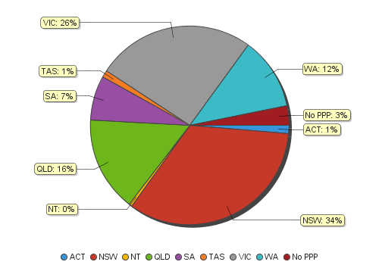
Chiropractic health practitioners – percentage by principal place of practice

Chiropractic health practitioners – endorsements by state or territory
Chiropractic health practitioners | Principal place of practice
Endorsement | ACT | NSW | NT | QLD | SA | TAS | VIC | WA | No PPP | Total
Acupuncture |  |  |  |  |  |  | 33 |  |  | 33

Chiropractic health practitioners – registration type and sub type by age group
Chiropractic health practitioners |  | Registration type and sub type
Age group |  | General | Limited |  | Non-practising | Total
 |  |  | Public interest | Teaching or research
U - 25 | 112 |  |  |  |  | 112
25 - 29 | 786 |  |  |  | 36 | 822
30 - 34 | 753 |  |  |  | 42 | 795
35 - 39 | 663 |  |  |  | 58 | 721
40 - 44 | 731 |  |  |  | 33 | 764
45 - 49 | 481 |  |  |  | 25 | 506
50 - 54 | 403 |  |  |  | 21 | 424
55 - 59 | 317 |  |  |  | 25 | 342
60 - 64 | 220 |  |  |  | 16 | 236
65 - 69 | 135 |  |  |  | 17 | 152
70 - 74 | 71 |  |  |  | 7 | 78
75 - 79 | 32 |  |  |  | 7 | 39
80+ | 12 |  |  |  | 2 | 14
Total | 4,716 |  |  |  | 289 | 5,005
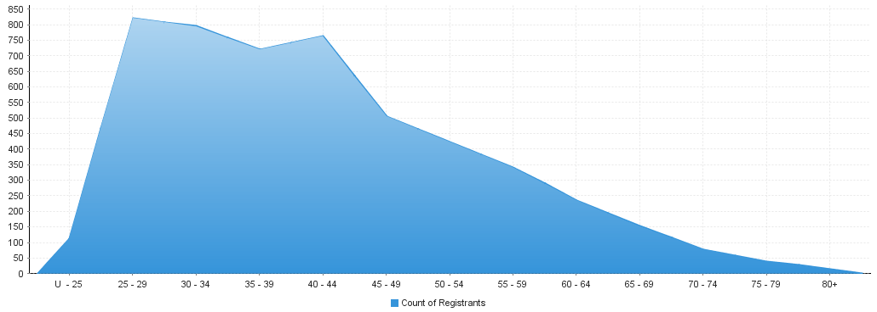
Chiropractic health practitioners – by age group
Age Group | U - 25 | 25 - 29 | 30 - 34 | 35 - 39 | 40 - 44 | 45 - 49 | 50 - 54 | 55 - 59 | 60 - 64 | 65 - 69 | 70 - 74 | 75 - 79 | 80+
Count of Registrants | 112 | 822 | 795 | 721 | 764 | 506 | 424 | 342 | 236 | 152 | 78 | 39 | 14

Chiropractic health practitioners – registration type and sub type by gender
Chiropractic health practitioners |  |  | Principal place of practice
Gender | Registration type | Registration sub type | ACT | NSW | NT | QLD | SA | TAS | VIC | WA | No PPP | Total
Female | General |  | 30 | 580 | 5 | 257 | 119 | 14 | 485 | 247 | 18 | 1,755
 | Limited | Public interest
 |  | Teaching or research
 | Non-practising |  | 2 | 29 | 1 | 7 | 8 | 1 | 37 | 4 | 36 | 125
Sub Total |  |  | 32 | 609 | 6 | 264 | 127 | 15 | 522 | 251 | 54 | 1,880
Male | General |  | 32 | 1,042 | 19 | 499 | 227 | 38 | 733 | 331 | 40 | 2,961
 | Limited | Public interest |  |  |  |  |  |  |  |  | 1 | 1
 |  | Teaching or research
 | Non-practising |  | 1 | 32 |  | 13 | 9 | 1 | 34 | 10 | 64 | 164
Sub Total |  |  | 33 | 1,074 | 19 | 512 | 236 | 39 | 767 | 341 | 104 | 3,125
Total |  |  | 65 | 1,683 | 25 | 776 | 363 | 54 | 1,289 | 592 | 158 | 5,005

Chiropractic health practitioners – percentage by gender
Chiropractic health practitioners | Principal place of practice
Gender | ACT | NSW | NT | QLD | SA | TAS | VIC | WA | No PPP | Total
Female | 49.23% | 36.19% | 24.00% | 34.02% | 34.99% | 27.78% | 40.50% | 42.40% | 34.18% | 37.56%
Male | 50.77% | 63.81% | 76.00% | 65.98% | 65.01% | 72.22% | 59.50% | 57.60% | 65.82% | 62.44%

